SDC Group Meeting – 7th April
Discussion:
- The group discussed the technical components of the website and how they would interact:
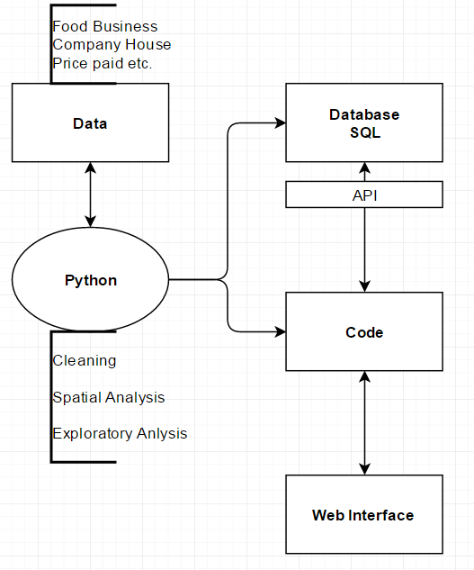
- The group discussed the datasets and different ways to analyse. The Companies House dataset suggested by Adam was downloaded and explored but difficulties found with large companies as only the location of headquarters would be shown. Advice was sought from Adam who suggested that the best way to filter the dataset would be by ‘Account Category’, ‘Total Exemption Small’ to get individual businesses.

- Leaders for the technical components were assigned:
- Web Design - Quiling
- Spatial Analysis - Claire
- SQL Interface - Duccio
- SQL Database – Jimmy
Each person will begin to explore their technical area to get a sense of ‘what is possible’ in relation to this project before Friday next week.
All group members will want to learn something about each area and will need to check each other’s work. It is therefore important to make code clear and include detailed comments for all work. Separate ‘Readmes’ are also a good idea if required.

The group listed tasks for exploratory data analysis to be completed by Friday next week (15 April) as listed below.
Jimmy (with help from Quiling):
- Explore the companies house dataset:
  - Download all the data and subset according to SIC code and account category
  - Add coordinates for London postcodes and map (using Claire’s code)
  - Do descriptive stats on the data, look at spatial trends by SIC code etc
  - Use Duccio’s code to look at tokens
- Look at SQL technical aspects required for the project.
Claire:
- Finish postcode code and add ability to plot points to a map in Python – Share with gr
- Look at census income and price paid data – produce maps showing areas of highprice/high income, changes etc.
- Review technical methods for spatial analysis
Duccio:
- Ensure token analysis code can be used by Jimmy for the new dataset
- Continue with text/token analysis
  - Start identifying which words are relevant
  - Look at analysis methods for combinations of words
  - Map tokens and look at spatial distributions
- Review technical methods for API/data/website interface
Quiling
- Assist Jimmy
- Review technical methods for web design
- Look at examples and libraries – come up with possible ideas for displaying our data and structuring the page
Get in touch with the group if you are having trouble!

Meeting Dates:
- Monday 11 April – Working day at CASA.
- Friday 15 April – Group meeting to start sketching out the website and project plan.
- Wednesday 20 April – Quiling is back – finalize sketch of website.

